Different ranges of celestial bodies

- Star ­ a large light producing object (through
nuclear fusion) whose gravity is large enough
to pull other objects near it.

Life of a star = nebula nuclear fusion core collapse
- Planet ­ an object, which orbits a star
- Satellite ­ an object which orbits a planet ex.
moons, artificial satellites
Galaxies
A galaxy is a massive group of stars, gas and dust
all held together by gravity.
Galaxies contain upwards to 100 billion stars.

You Earth Solar System Milky Way Galaxy
Earth is a planet in our solar system. Our solar system is one of many in the Milky Way Galaxy.
The Milky Way Galaxy is one of many in the Universe.
The Milky Way is 75 000 light years in diameter. It
is a spiral galaxy because of its shape. The Sun is
located near the outer part of the spiral.
The band that we can see occupies about 400
billion stars.
The main types of galaxies are:
Spiral - galaxy with tightly wound spiral arms
Elliptical - slightly elliptical to nearly circular
Barred Spiral - spiral with a bright bar of gas through the center
Peculiar - fits none of the descriptions
Irregular - small, patchy, irregularly shaped galaxy
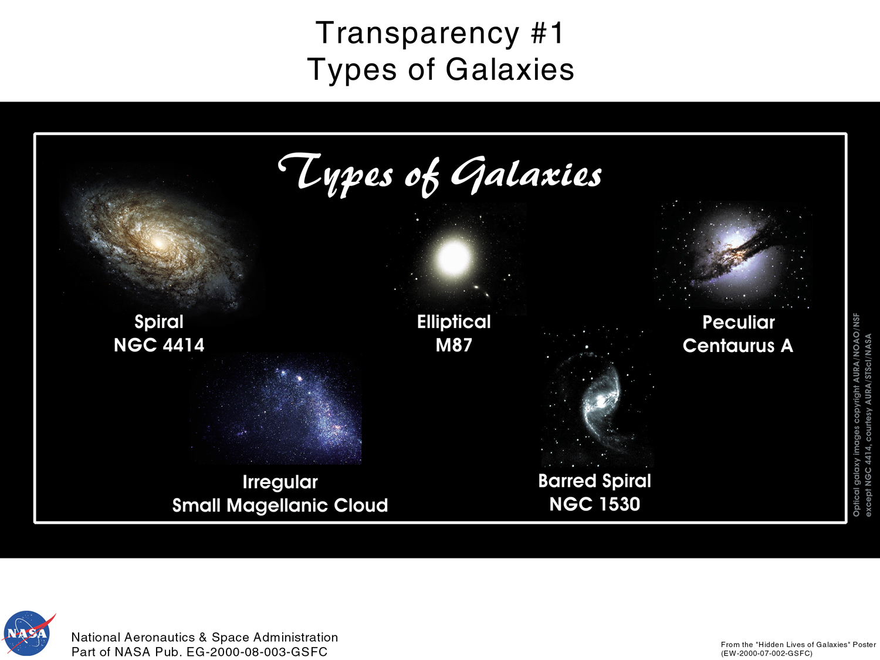

The closest galaxy to us is called Andromeda (2.5 million light years away). It is visible with the naked eye! It was discovered by Edwin
Hubble in 1925.

The "Hubble Deep Field" image was taken by the Hubble Space Telescope December 18 - 28, 1995. It was taken of a region near the handle of the Big Dipper, and covers a patch of sky about only 0.05 degrees across (equivalent to the width of a dime viewed 75 feet away). This region was chosen because there are very few stars there. So nearly every object in the image is a galaxy.
Using the “Hubble Deep Space Image” identify the types of the ten galaxies labeled on the Deep Survey Image.
